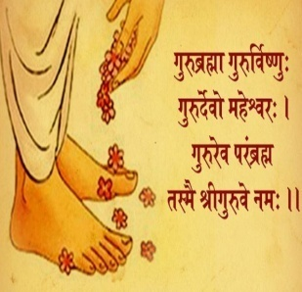

Dear Students,
It is good to have you all back after the long and hot summer vacation. I am sure you had lots of fun during the holidays but I was missing you so much! It was so empty without you.
It was like a sky without a rainbow but now you have come back it will again be filled with fun and joy.
Here is a short schedule of your studies during this month for you and your parents. Please go through it so that you don't miss out anything.
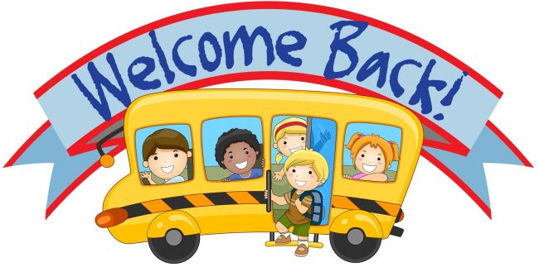

SYLLABUS
Eng – Written Small cursive letters b, c, d
Hindi- Written व्यंजन ख, ग, घ, ड, च लिखो
Maths- Written Missing counting 1 to 50, Write counting 1 to 50, What comes after,
Number name one - 1
Eng Rhymes: Good night, Humpty Dumpty
कविता: मेरा बस्ता, टेलिफोन
Maths-Oral Counting 1 to 50, Number Name One-1,Two-2, Three-3
GK Fruits name, Vegetable names, Colour names
Music Maa Saraswati prayer
Dance PK movie song- Aayo re
Conversation 1. How many days are there in a week?
2. What is the name of our principal madam?
3.Which is the first and last month of the year?
4.Which is the shortest month of the year?
Activities & Celebration
11th ,12th & 13th July Hygiene Days:
11th July Hand wash Activity(Bring Sanatizer)
12th July Brush your Teeth( bring Toothbrush)
13th July Shoe polish & socks Washing
(Bring Shoe polish brush)
14th July Pool Party
(Bring Swimming costume or cycling shorts with
T-shirt, Towel)
( Prizes for best dress will be given)
28th July Birthday Celebration & Movie day
Days to remember:
1st 1st July Docter’s day
8th July Guru Poornima
11th July World Population day
26th July Kargil Vijay Diwas
